Chapter 2
Fungal characteristics
Some physical and physiological characteristics of fungi can be useful in identifying fungi to various levels of hierarchical classification. Farmers with an understanding of fungal characteristics are also at an advantage in manipulating them to the benefit of their crop. In this chapter we will be discussing different anatomical features that researchers and growers can use to help identify the particular fungus with which they are working. We will be describing some of the key features that make a fungus a fungus, and not, for instance, a plant. The goal of this chapter is to develop a better understanding and appreciation of fungi.

Historically fungi have been grouped closely with plants. To this day, within academia, fungi are generally reserved for the purview of the botanists. Universities with a “Department of Mycology” are exceedingly rare. When a university department or college does include “mycology” in its title, it is almost always paired with the “botany” or “plant pathology” department. While there is a level of logic behind this, as these two kingdoms are intimately linked in practice through symbioses, the original grouping of fungi and plants together was an academic mistake.
Fungi superficially grow similarly to plants, with macroscopic forms appearing as sessile organisms with cell walls similar to plants and dependent on dispersal of reproductive structures for survival. Botanists, beginning with Pier Antonio Micheli, who published Nova plantarum genera in 1729, were the first western scientists to pioneer the study of fungi. Pier Antonio Micheli was the first person to show fungi reproduce via spores. Before his experiments showing that spores transferred to a new substrate gave rise to the same species of fungi from which they came, the dominant view had been that fungi spontaneously generate.
The scientific study of mushrooms was mostly confined within botanical taxonomy for the next hundred years or so, pioneered by Carolus Linnæus. Linneaus’s work was expanded upon by other botanists, such as Christiaan Hendrik Persoon and Elias Magnus Fries. The person widely considered the father of plant pathology and mycology is Heinrich Anton de Bary. De Bary proved that potato blight was caused by an infectious agent, Phytophthora infestans. Before this work people believed pathogenic organisms on diseased plants were a result of host illness, and not the cause. De Bary also intensively studied lichens and coined the terms “symbiosis” and “endophyte.”
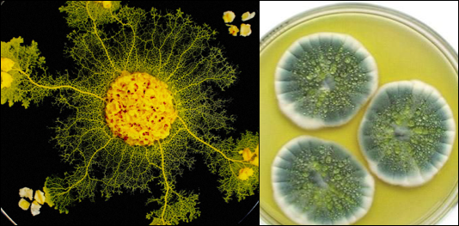
Fig. 2.1 Slime mold (left) vs a true fungus, Penicillium spp. (right).
Throughout this period fungi were considered lower plants. Ironically, this tradition of grouping unrelated organisms within an unrelated field continues; the Amoebozoid ‘slime molds’ (Myxostelida, Dictyostelida, Labyrinthulida, and Plasmodiophorida) and the Chromistan ‘fungi’ (Oomycota, Fig. 2.1) are not true fungi. Nonetheless, the similarity of physical appearance, growth characteristics, and economic impacts of these organisms reinforce their retention as a related field to mycology (and likewise mycology to botany). In fact, the aforementioned Phytophthora infestans, among the most famous ‘fungal’ plant diseases of all time due to the Irish Potato Famine, isn't a fungus at all; it’s an Oomycete (Heterokonta). Incidentally, Oomycetes are referred to by the confusing common name of ‘water molds.’ This is the same class that contains the genus Pythium, a common cause of damping off among seedlings of many plant species. Thus, the academic linkage of Plant Pathology and Mycology becomes clear.

Table 2.1. Hierarchical classification of 3 domains of life.
Domain | Kingdom | Members
Bacteria | Bacteria | Actinobacteria (Actinomycetota), Proteobacteria (Pseudomonadota), Cyanobacteria (Cyanophyta), Spirochaete (Spirochaetota), ect.
Archaea | Archaea | Extremophiles, methanogens
Eukaryota | Excavata | Various flagellate protozoa
 | Amoebozoa | Most lobose amoeboids and slime molds
 | Opisthokonta | Animals, fungi, choanoflagellates
 | Rhizaria | Radiolaria, and various other amoeboid protozoa
 | Chromalveolata | Stramenopiles (Brown Algae, Diatoms etc.), Haptophyta, Cryptophyta (or cryptomonads), and Alveolata
 | Archaeplastida | Land plants, green algae, red algae, and glaucophytes

Plants and Fungi
The relatedness of fungi and plants has stumped scientists for generations. In the past, scientists were only able to observe morphological characteristics in these organisms and did their best to group them based on these features. Chemical taxonomy helped prove that fungi were physiologically distinct from plants in numerous ways (Figure 8). The aid of molecular genetic sequencing techniques has recently helped further unravel the many mysteries about the relatedness of fungi. Organisms once believed to be fungi have been reclassified as protozoa (including oomycetes and the mycetozoan slime molds,); organisms believed to be protozoa (such as Chytrids, Microsporidia, and Pneumocystis jirovecii) were shown to be fungi. Protozoa itself is a catch-all group of single celled organisms that is non-monophyletic, meaning the grouping contains organisms descending from different groups of ancestors. Therefore it serves only as a classification rather than a systematic grouping representing phylogeny.
As stated before, plants and fungi share a number of similar characteristics but there are also some key differences between the two. To begin, both organisms are eukaryotic with membrane bound organelles, including a nucleus that houses the genetic material, deoxyribonucleic acid (DNA). However, fungi have relatively small nuclei with little repetitive DNA. Fungi can have one to many nuclei per ‘cell.’ Often these are genetically distinct nuclei when plasmogamy (the fusion of independent mycelial bodies) has occurred in the individual's history. Previously, separate individual mycelia may merge together in this way if they have appropriately-matched vegetative or mating compatibility types. Fungi usually have haploid
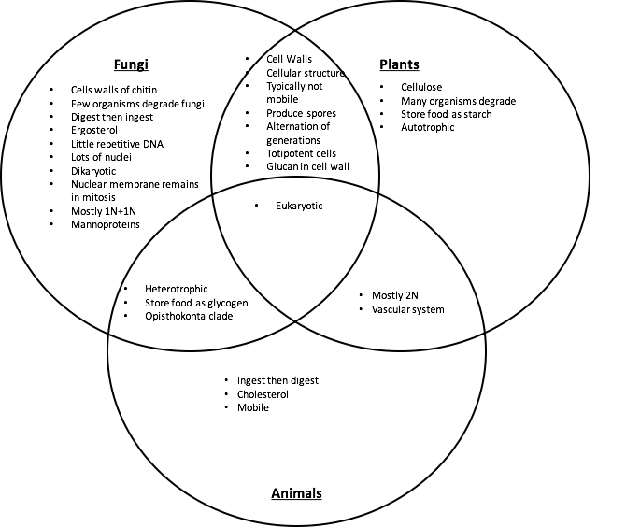
Figure 2.2. Venn diagram comparing similarities and differences of fungal, plant, and animal characteristics.

nuclei, even when two (or more) genetically unique nuclei coexist in an individual. Karyogamy (nuclear fusion) resulting in 2n nuclei only occurs in certain cells within fruiting bodies. These 2n nuclei form preceding the sexual production of gametes via meiosis. Higher plants have relatively large nuclei that are often diploid in all cells except the gametes, pollen and ovules. This is similar to animals. Ferns, on the other hand, are an ancestral plant lineage which have extended 1n gametophyte stages. There are even a few species of ferns, including the Appalachian gametophyte, Vittaria appalachiana, that do not have a known sporophyte stage. This is analogous to many fungal ‘molds’ which are only known to exist in asexual forms.
A structure that both plant and fungal cells produce, and which serves many of the same functions, is the cell wall. The cell wall permits both plants and fungi to form sturdy structures capable of above ground growth by adding rigidity to tissue. Cell walls also assist in growth through physical substrates by permitting turgid fungal hyphae and plant tissue to exert outward osmotic pressure without the cell membrane rupturing. This is a crucial factor for the apical growth of hyphae among fungi through a physical substrate (Money, 1995), as it is in root tips and pollen tubes among plants. Additionally, cell walls serve to protect the cellular components and organelles found within. Despite similarities in function, the composition of the cell walls fundamentally differs between plants and fungi. Plants have cell walls composed of cellulose (and sometimes lignin) whereas fungi have cell walls of chitin.

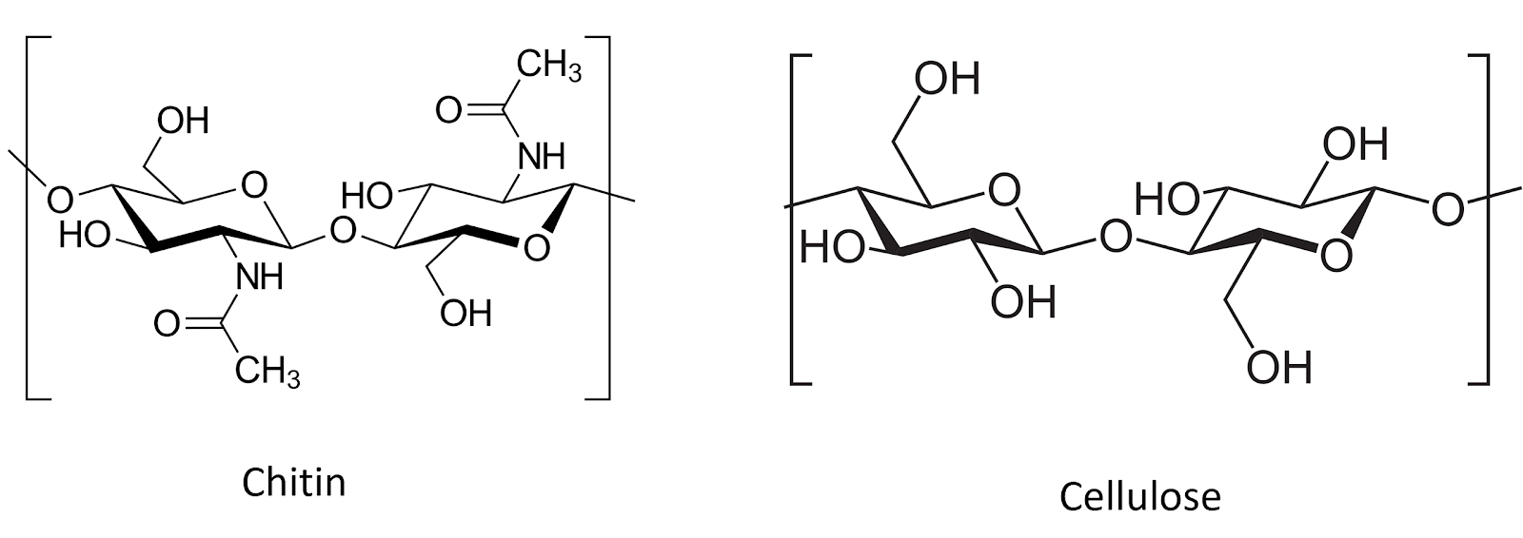
Figure 2.3. Chitin and cellulose are both polysacharide chains of β1-4 linked monosacharide monomers. Chitin comprises chains of N-Acetylglucosamine monomers, whereas cellulose is made of D-glucose monomers (graphic from wiki commons).

Due to the rigidity of the cell walls, both plants and fungi are generally sessile when mature. As sessile organisms, the lifestyle of plants and fungi are much different because of how each must acquire food. Plants are photoautotrophic and therefore able to produce their own food by utilizing sunlight energy to fix atmospheric carbon via photosynthesis into sugars. They also rely on root systems to gather essential elemental nutrients from the medium in which they grow. Plants metabolize sugars via cellular respiration as a source of stored energy. They also use the sugar they create, along with elemental nutrients from the soil, as substrates to synthesize the complex organic compounds their bodies require to live. In contrast, heterotrophs are unable to produce their own food and must acquire nutrition and carbon from the consumption of other organisms or their byproducts (Figure #XXX)..
Fungi are chemoheterotrophic, meaning they must acquire organic carbon (rather than inorganic carbon dioxide) from the environment. These acquired nutrients serve as both their source of chemical energy and the necessary substrates from which their cellular machinery and bodies are produced. They are entirely reliant on acquiring nutrients and food from the environment. Ultimately, all of every fungi’s food is directly or indirectly sourced from carbon based molecules produced from the fixation of atmospheric carbon dioxide (CO₂) by plants. The same is true for ourselves as humans, as well as every other heterotrophic organism (save those lifeforms whose food is derived from the action of prokaryotic chemoautotrophs, such as the extremophiles which survive in sulfur springs or form the basis of the food webs of deep sea vents).
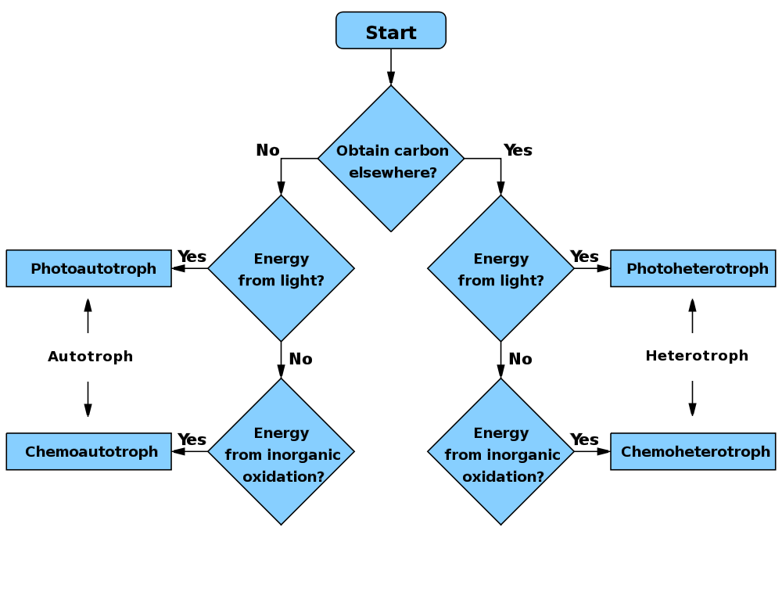
Figure 2.4. WikiCommons user: Wickey-nl
While fungi are generally ‘non-motile,’ their cells are connected in such a way as to allow much of the cytoplasmic contents to flow through the tubular hyphae. In this way, a fungus can transport nutrients around its mycelium. While a fungus cannot move its existing body to a new location, they are able to exploit cytoplasmic flow in order to change or expand locations by growing hyphae in new directions, flowing their cytoplasm into the newly formed mycelial body, and walling off older sections of their mycelium. Thus, they may gain functional motility beyond that of most plants, despite lacking moving appendages with musculature, and while maintaining a rigid cell wall which prevents ameboid movement via pseudopodia (although some yeasts can move in this fashion).
Another implication of being unable to move is that fungi, like plants, cannot evade predators. Therefore, they are forced to come up with alternate defense mechanisms. Plants can develop thorns and spikes as part of their physical structure to discourage predators from attacking, however, they also produce a variety of novel secondary metabolites that act as defense compounds. Some fungi have developed physical defense structures, such as lacticifers among Lactarius or the physical toughness of many perennial polypores, but the production of secondary metabolites to ward off competitors or predators is ubiquitous. Some of these compounds include famous antibiotics, such as penicillin and its derivatives, or citric acid , a common food additive that is produced from Aspergillus niger fermentation. The plethora of secondary metabolites from fungi is astonishingly diverse and includes varying polyketides, terpenoids, terpenes, alkaloids, and peptides (Keller et al, 2005).

Animals and Fungi
There are a number of other key similarities and differences in plants and fungi, however, fungi are actually closer to animals than plants (Figure #XXX). Animals, plants and fungi are all eukaryotic, with DNA contained in a nuclei and membrane-bound organelles, representing their common lineage. However, plants split away from the ancestors of fungi and animals first. Today, fungi and animals are both placed within the clade Opisthokonta. A common trait of this clade is mobile gametes at some point in the organisms’ lifecycle. Only the basal lineages of fungi have retained motile gametes, as have humans (sperm). Most fungi no longer produce flagellated gametes.
Obviously, most animals are mobile organisms that are adept at moving around to find nutrients and food, and evade predators. The lack of cell walls is important for permitting contraction and relaxation of muscle cells, on which animal movement depends. The relative rigidity of mature fungal cells conferred by cell walls prevents contractile-relaxation of tissue, as well as ameboid-like formation of pseudopodia.
Both animals and fungi are chemoheterotrophic. In general, neither can produce their own food and cannot use light as an energy source. Thus, animals will ingest and then digest their food, whereas fungi digest (by releasing exoenzymes into the environment) and then ingest (by actively transporting nutrients back into the fungal body). An exception to this is that various animals, such as members of the Sacoglossan sea slugs, can become photosynthetic by sequestering entire photosynthetic microbes -or even just their chloroplasts (a phenomenon known as kleptoplasty). The animals may then acquire the ability to derive energy from photosynthesis.
A physiological difference with practical implications between fungi and animals is the structure of sterols embedded in their cell membranes. Fungi synthesize ergosterol whereas animals synthesize cholesterol (plants also produce a diverse array of phytosterols). Both ergosterol and cholesterol are derived from the same precursor, lanosterol (Fig. #XXX). Ergosterol and cholesterol serve similar functions including impacting membrane fluidity, cell signaling and other physiological processes. One reason we are focusing on this particular molecular difference between fungi and animals is that we can exploit the ergosterol pathway unique to fungi in order to develop and apply selective fungicides. Compared to prokaryotic pathogens and disease agents, parasitic and pathogenic fungi have much more in common physiologically with their eukaryotic plant and animal hosts. Therefore, ergosterol and its biosynthesis are particularly important targets for antifungal compounds in agriculture, as well as veterinary and human medicine. .
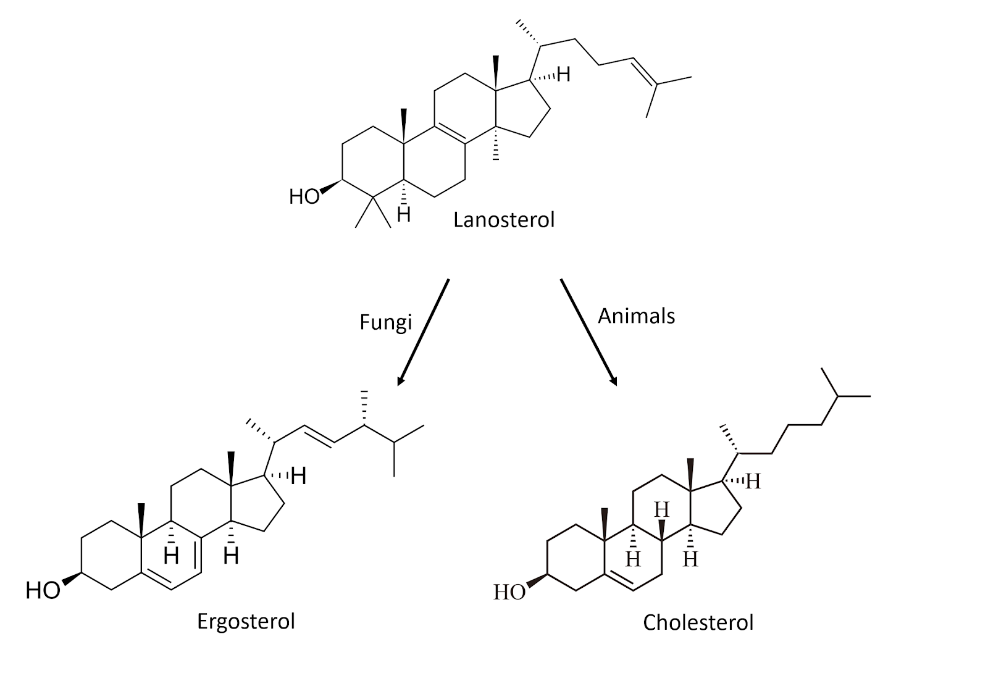
Figure 2.5. Chemical structures for sterol compounds found in fungi (Ergosterol) and animals (Cholesterol)

Fungi are an extremely unique and diverse group of organisms that contain some characteristics not found anywhere else in nature. The varied growth forms are reliant on external digestion of substrate by secreted exoenzymes, followed by ingestion of the predigested food via absorption and endocytosis. That fungi can be mono- or dikaryotic, some with many nuclei per ‘cell,’ is not only fascinating, but allows fungi unique physiological and evolutionary paths compared to uninucleate organisms. Also, among filamentous fungi, cells can behave a little differently than one usually thinks of when considering traditional biological cell; the entire vegetative body, the mycelium, can exist as a complex network which nevertheless functions as though it is a single cell due to the ability of its cytoplasm to flow freely. Yeast cells are more akin to what most people think of when pondering single-celled organisms.

Fungal Identification
Identification of fungi is similar to plants; vegetative characteristics are much less reliable than reproductive characters for identification purposes. This is likely because the precision of reproduction -particularly sexual reproduction- requires the conservation of function, and therefore the form of the relevant structures. Among fungi that produce sporocarps (sexual fruiting bodies, including any that people call mushrooms), the features of the structure and the resultant spores are crucial for proper identification. Analogously, among asexually reproducing ‘molds,’ the asexual reproductive structures are important features for identification (conidia and conidiophores, zygospores and zygosporangia, glomerospores, ect).
Many times, farmers encounter fungi that lack identifying characters. For instance, observing a soil sample through a microscope can give you an idea if fungal hyphae are present, but often not enough to discern the identity or role the fungus is playing in the soil. One can look at the diameter of hyphal strands and the presence or absence of septa and clamp connections but this only gives the most general information about the clade to which the fungi may belong.
Morphological based identification of fungi has inherent flaws. It can be complex and is not always an accurate representation of what is really there. Many fungi do not readily produce spores, sexual or asexual. Sterile mycelia is usually impossible to identify visually. Sometimes you may coax spore production from such fungi via culture-based methods (such as growing cultures in various light, temperature, and media). However, culture-based methods can under-represent or exclude fungi difficult or unable to be cultures. Molecular tools that overcome some of these obstacles may be used to identify species in complex microbial communities or occult individuals. Genetic sequencing is becoming increasingly available and will be a valuable tool to incorporate for farmers in the future.
Perhaps most importantly for farmers, those able to identify fungi acting as pathogens affecting their crop have an advantage. For any fungus, the context in which it occurs will be the starting point from which we can begin to home in on its identity. Simply being pathogenic on Cannabis narrows the potential identity greatly. Usually, fungal pathogens affecting Cannabis also readily produce reproductive structures that aid in proper identification.

